**Project 3 Part 1 (Closest pair – Brute force)**

Name: Vivian Feng Period: 5

Date: 10/12/2022

Is your lab name l031?(lowercase L followed by digits 031) Yes

Did you created a class to store a point? Yes

Did you use a list to store the points you generated? Yes

Did you use at least one iterator to traverse the list you created? Yes

Does your main contain only the calls of methods part0() and part1()? Yes

Did you compile and run your code on jupyterhub? Yes

Did you calculate every distance between any points only once? Yes

Paste here a clear picture of the ppm you obtained in 2 random runs that displays all the points generated in black with the 2 closest points in a different color (red) (use a bold circle of radius 3 for each point you plot) using a white background:

----------------------------------------------------------Run 1-------------------------------------------------------------------------

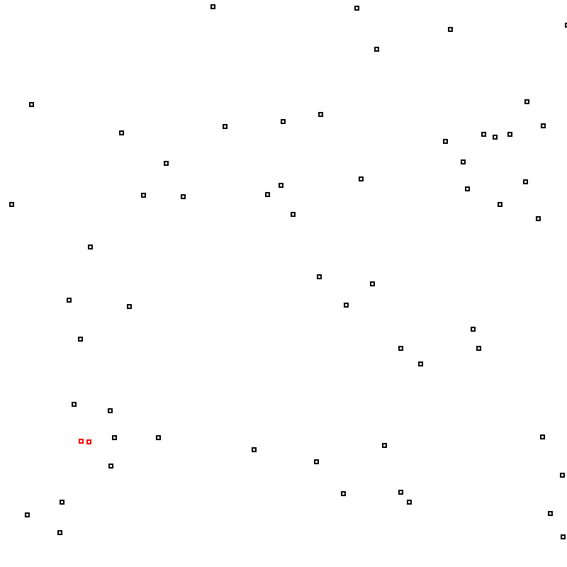

----------------------------------------------------Run 2 ------------------------------------------------------------------------------